Perpendicularity Conditions

Definition
# Source: AI Source: Provided by: [Data Path: Persons Table -> ID Column: 1, Name_En Column: Motasem Essam] -> From: [ChatGPT] on [7/25/2026]
Perpendicularity Conditions are geometric conditions that require two geometric objects to meet or intersect at a right angle.
For two intersecting lines $l_{1}$and $l_{2}$:
$$\boxed{l_{1}⊥l_{2}}$$
means that the lines are perpendicular.
The defining angle relationship is:
$$\boxed{{90}^{∘}}$$
or, in radians:
$$\boxed{\frac{π}{2}}.$$
Perpendicularity can occur between:
- lines
- line segments
- rays
- planes
- lines and planes
- sides and diagonals
- altitudes
- perpendicular bisectors
- geometric axes

Simple Definition
# Source: AI Source: Provided by: [Data Path: Persons Table -> ID Column: 1, Name_En Column: Motasem Essam] -> From: [ChatGPT] on [7/25/2026]
A Perpendicularity Condition is a geometric requirement that two objects intersect or meet at a right angle.
Example:
$$\boxed{AB⊥CD}$$
means $AB$and $CD$meet at ${90}^{∘}$.

Classification of Perpendicularity Conditions
# Source: AI Source: Provided by: [Data Path: Persons Table -> ID Column: 1, Name_En Column: Motasem Essam] -> From: [ChatGPT] on [7/25/2026]
A practical classification is:
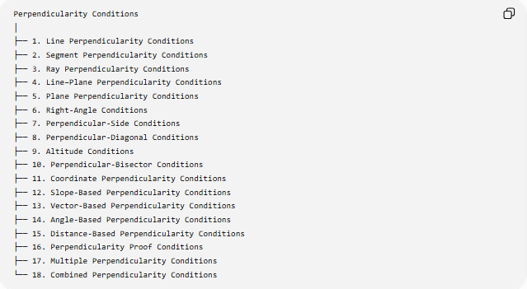
Perpendicularity Conditions
│
├── 1. Line Perpendicularity Conditions
├── 2. Segment Perpendicularity Conditions
├── 3. Ray Perpendicularity Conditions
├── 4. Line–Plane Perpendicularity Conditions
├── 5. Plane Perpendicularity Conditions
├── 6. Right-Angle Conditions
├── 7. Perpendicular-Side Conditions
├── 8. Perpendicular-Diagonal Conditions
├── 9. Altitude Conditions
├── 10. Perpendicular-Bisector Conditions
├── 11. Coordinate Perpendicularity Conditions
├── 12. Slope-Based Perpendicularity Conditions
├── 13. Vector-Based Perpendicularity Conditions
├── 14. Angle-Based Perpendicularity Conditions
├── 15. Distance-Based Perpendicularity Conditions
├── 16. Perpendicularity Proof Conditions
├── 17. Multiple Perpendicularity Conditions
└── 18. Combined Perpendicularity Conditions

1. Line Perpendicularity Conditions
# Source: AI Source: Provided by: [Data Path: Persons Table -> ID Column: 1, Name_En Column: Motasem Essam] -> From: [ChatGPT] on [7/25/2026]
Definition
A Line Perpendicularity Condition requires two intersecting lines to form a right angle.
$$\boxed{l_{1}⊥l_{2}}$$
Example
If:
$$m∠A={90}^{∘}$$
at the intersection of $l_{1}$and $l_{2}$, then:
$$\boxed{l_{1}⊥l_{2}}.$$
Important property
Perpendicular lines intersect.
Therefore, in the Euclidean plane:
$$l_{1}⊥l_{2}$$
implies:
$$l_{1}∩l_{2}=P$$
for some point $P$.

2. Segment Perpendicularity Conditions
# Source: AI Source: Provided by: [Data Path: Persons Table -> ID Column: 1, Name_En Column: Motasem Essam] -> From: [ChatGPT] on [7/25/2026]
Definition
A Segment Perpendicularity Condition requires two segments to intersect at a right angle.
Example:
$$\boxed{\overset{‾}{AB}⊥\overset{‾}{CD}}.$$
Example
Suppose two segments intersect at $P$, and:
$$∠APC={90}^{∘}.$$
Then:
$$\boxed{\overset{‾}{AB}⊥\overset{‾}{CD}}.$$
The segments themselves are finite, but their supporting lines are also perpendicular.

3. Ray Perpendicularity Conditions
# Source: AI Source: Provided by: [Data Path: Persons Table -> ID Column: 1, Name_En Column: Motasem Essam] -> From: [ChatGPT] on [7/25/2026]
Definition
A Ray Perpendicularity Condition requires two rays with a common endpoint to form a ${90}^{∘}$angle.
Example:
$$\boxed{\vec{AB}⊥\vec{AC}}$$
means:
$$\boxed{∠BAC={90}^{∘}}.$$
Example
If:
$$∠BAC={90}^{∘},$$
then rays $\vec{AB}$and $\vec{AC}$are perpendicular.

4. Line–Plane Perpendicularity Conditions
# Source: AI Source: Provided by: [Data Path: Persons Table -> ID Column: 1, Name_En Column: Motasem Essam] -> From: [ChatGPT] on [7/25/2026]
Definition
A Line–Plane Perpendicularity Condition occurs when a line is perpendicular to every line in a plane passing through their point of intersection.
The notation is:
$$\boxed{l⊥Π}.$$
Example
A vertical pole standing perpendicular to a horizontal floor can be modeled as:
$$\boxed{l⊥Π}.$$
Characterization
A line is perpendicular to a plane if it is perpendicular to two intersecting lines in the plane at their common point.
Thus:
$$l⊥l_{1}, l⊥l_{2},$$
where $l_{1},l_{2}⊂Π$intersect, implies:
$$\boxed{l⊥Π}.$$

5. Plane Perpendicularity Conditions
# Source: AI Source: Provided by: [Data Path: Persons Table -> ID Column: 1, Name_En Column: Motasem Essam] -> From: [ChatGPT] on [7/25/2026]
Definition
Two planes are perpendicular when their dihedral angle is ${90}^{∘}$.
Notation:
$$\boxed{Π_{1}⊥Π_{2}}.$$
Example
Two walls meeting at a right angle can be modeled as perpendicular planes.
Important distinction
Perpendicular planes normally intersect.
Therefore:
$$Π_{1}⊥Π_{2}$$
is fundamentally different from:
$$Π_{1}∥Π_{2}.$$

6. Right-Angle Conditions
# Source: AI Source: Provided by: [Data Path: Persons Table -> ID Column: 1, Name_En Column: Motasem Essam] -> From: [ChatGPT] on [7/25/2026]
Definition
A Right-Angle Condition specifies that an angle must equal ${90}^{∘}$.
$$\boxed{m∠A={90}^{∘}}.$$
This is the fundamental angular expression of perpendicularity.
Example
If:
$$∠ABC={90}^{∘},$$
then:
$$\boxed{BA⊥BC}.$$
Thus:
$$\boxed{\text{Perpendicularity }⟺\text{ Right Angle}}$$
for intersecting lines/rays in the plane.

7. Perpendicular-Side Conditions
# Source: AI Source: Provided by: [Data Path: Persons Table -> ID Column: 1, Name_En Column: Motasem Essam] -> From: [ChatGPT] on [7/25/2026]
Definition
A Perpendicular-Side Condition specifies that two sides of a figure meet at a right angle.
Example: rectangle
Every pair of adjacent sides of a rectangle is perpendicular:
$$\boxed{AB⊥BC} \\ \boxed{BC⊥CD} \\ \boxed{CD⊥DA} \\ \boxed{DA⊥AB}.$$
Square
A square also satisfies the same perpendicular-side relationships.

8. Perpendicular-Diagonal Conditions
# Source: AI Source: Provided by: [Data Path: Persons Table -> ID Column: 1, Name_En Column: Motasem Essam] -> From: [ChatGPT] on [7/25/2026]
Definition
A Perpendicular-Diagonal Condition specifies that the diagonals of a figure intersect at ${90}^{∘}$.
Example: rhombus
The diagonals of a rhombus are perpendicular:
$$\boxed{AC⊥BD}.$$
Important distinction
Not every quadrilateral has perpendicular diagonals.
For example, a general rectangle does not normally have perpendicular diagonals.
A square is a special case where its diagonals are perpendicular.

9. Altitude Conditions
# Source: AI Source: Provided by: [Data Path: Persons Table -> ID Column: 1, Name_En Column: Motasem Essam] -> From: [ChatGPT] on [7/25/2026]
Definition
An Altitude Condition requires a segment from a vertex to the opposite side or its extension to be perpendicular to that side.
For triangle $ABC$, if $D$lies on $BC$and:
$$\boxed{AD⊥BC},$$
then $AD$is an altitude.
Example
If:
$$BC=10$$
and:
$$AD⊥BC,$$
with:
$$AD=6,$$
then the triangle area is:
$$K=\frac{1}{2}\left(10\right)\left(6\right)=30.$$
Thus:
$$\boxed{K=30}.$$

10. Perpendicular-Bisector Conditions
# Source: AI Source: Provided by: [Data Path: Persons Table -> ID Column: 1, Name_En Column: Motasem Essam] -> From: [ChatGPT] on [7/25/2026]
Definition
A Perpendicular-Bisector Condition requires a line to:
- be perpendicular to a segment, and
- pass through its midpoint.
For segment $\overset{‾}{AB}$, if $M$is its midpoint:
$$AM=MB$$
and:
$$\boxed{l⊥AB},$$
then $l$is the perpendicular bisector of $AB$.
Fundamental locus property
Every point $P$on the perpendicular bisector satisfies:
$$\boxed{PA=PB}.$$
Conversely:
$$PA=PB$$
implies that $P$lies on the perpendicular bisector of $AB$.
Therefore:
$$\boxed{PA=PB ⟺ P\text{ lies on the perpendicular bisector of }AB}$$

11. Coordinate Perpendicularity Conditions
# Source: AI Source: Provided by: [Data Path: Persons Table -> ID Column: 1, Name_En Column: Motasem Essam] -> From: [ChatGPT] on [7/25/2026]
Perpendicularity can be tested using coordinates.
For two non-vertical lines:
$$y=m_{1}x+b_{1}$$
and:
$$y=m_{2}x+b_{2},$$
they are perpendicular when:
$$\boxed{m_{1}m_{2}=-1}.$$
Example
Consider:
$$l_{1}:y=2x+1$$
and:
$$l_{2}:y=-\frac{1}{2}x+4.$$
Their slopes are:
$$m_{1}=2, m_{2}=-\frac{1}{2}.$$
Therefore:
$$m_{1}m_{2}=2\left(-\frac{1}{2}\right)=-1.$$
Thus:
$$\boxed{l_{1}⊥l_{2}}.$$

12. Vertical and Horizontal Lines
# Source: AI Source: Provided by: [Data Path: Persons Table -> ID Column: 1, Name_En Column: Motasem Essam] -> From: [ChatGPT] on [7/25/2026]
A horizontal line has slope:
$$m=0.$$
A vertical line has undefined slope.
They are perpendicular.
For example:
$$y=4$$
and:
$$x=7$$
satisfy:
$$\boxed{y=4⊥x=7}.$$
This is an important case where the product rule $m_{1}m_{2}=-1$cannot be applied directly because one slope is undefined.

13. Vector-Based Perpendicularity Conditions
# Source: AI Source: Provided by: [Data Path: Persons Table -> ID Column: 1, Name_En Column: Motasem Essam] -> From: [ChatGPT] on [7/25/2026]
Definition
Two vectors are perpendicular when their dot product is zero.
$$\boxed{\vec{u}⋅\vec{v}=0}.$$
Example
Let:
$$\vec{u}=\left(2 , 3\right)$$
and:
$$\vec{v}=\left(3 , -2\right).$$
Then:
$$\vec{u}⋅\vec{v}=\left(2\right)\left(3\right)+\left(3\right)\left(-2\right) \\ =6-6 \\ =0.$$
Therefore:
$$\boxed{\vec{u}⊥\vec{v}}.$$

14. Angle-Based Perpendicularity Conditions
# Source: AI Source: Provided by: [Data Path: Persons Table -> ID Column: 1, Name_En Column: Motasem Essam] -> From: [ChatGPT] on [7/25/2026]
The most direct angle condition is:
$$\boxed{θ={90}^{∘}}.$$
Using radians:
$$\boxed{θ=\frac{π}{2}}.$$
Example
If:
$$∠ABC={90}^{∘},$$
then:
$$\boxed{AB⊥BC}.$$
Vector angle formula
For two nonzero vectors:
$$\cos{θ}=\frac{\vec{u}⋅\vec{v}}{∣\vec{u}∣∣\vec{v}∣}.$$
For perpendicular vectors:
$$θ={90}^{∘}$$
and:
$$\cos{{90}^{∘}}=0,$$
so:
$$\vec{u}⋅\vec{v}=0.$$

15. Distance-Based Perpendicularity Conditions
# Source: AI Source: Provided by: [Data Path: Persons Table -> ID Column: 1, Name_En Column: Motasem Essam] -> From: [ChatGPT] on [7/25/2026]
Perpendicularity is closely related to shortest distance.
If $P$is outside line $l$, and $H$is the foot of the perpendicular:
$$PH⊥l,$$
then:
$$\boxed{PH≤PQ}$$
for every $Q∈l$.
Therefore:
$$\boxed{PH=d\left(P , l\right)}.$$
This means the perpendicular segment represents the shortest distance from a point to a line.
Example
If:
$$PH=5$$
and $Q$is any other point on $l$, then:
$$\boxed{PQ≥5}.$$

16. Perpendicularity Proof Conditions
# Source: AI Source: Provided by: [Data Path: Persons Table -> ID Column: 1, Name_En Column: Motasem Essam] -> From: [ChatGPT] on [7/25/2026]
Perpendicularity is frequently the conclusion of a geometry proof.
Method 1 — Right angle
Show:
$$m∠ABC={90}^{∘}.$$
Therefore:
$$\boxed{AB⊥BC}.$$
Method 2 — Slopes
Show:
$$m_{1}m_{2}=-1.$$
Therefore:
$$\boxed{l_{1}⊥l_{2}}.$$
Method 3 — Dot product
Show:
$$\vec{u}⋅\vec{v}=0.$$
Therefore:
$$\boxed{\vec{u}⊥\vec{v}}.$$
Method 4 — Pythagorean converse
If:
$$AB^{2}+AC^{2}=BC^{2},$$
then:
$$\boxed{∠A={90}^{∘}}.$$
Therefore:
$$\boxed{AB⊥AC}.$$

17. Multiple Perpendicularity Conditions
# Source: AI Source: Provided by: [Data Path: Persons Table -> ID Column: 1, Name_En Column: Motasem Essam] -> From: [ChatGPT] on [7/25/2026]
Definition
A Multiple Perpendicularity Condition requires several objects to be perpendicular to one or more other objects.
Example
Suppose:
$$l_{1}⊥t$$
and:
$$l_{2}⊥t.$$
Then:
$$l_{1}∥l_{2}.$$
Another example:
In a rectangle:
$$AB⊥BC$$
and:
$$BC⊥CD.$$
Multiple right-angle relationships determine the rectangular structure.

18. Combined Perpendicularity Conditions
# Source: AI Source: Provided by: [Data Path: Persons Table -> ID Column: 1, Name_En Column: Motasem Essam] -> From: [ChatGPT] on [7/25/2026]
Definition
A Combined Perpendicularity Condition combines perpendicularity with other geometric requirements.
Example
Suppose $D$lies on $BC$, and:
$$D∈\overset{‾}{BC}$$
and:
$$AD⊥BC.$$
Then $AD$is an altitude.
If additionally:
$$BD=DC,$$
then $AD$is both:
- an altitude
- a median
and, in an appropriate isosceles-triangle configuration, it can also be an angle bisector.
Combined condition
$$\boxed{D∈\overset{‾}{BC}∧AD⊥BC∧BD=DC}$$

Perpendicularity and Parallelism
# Source: AI Source: Provided by: [Data Path: Persons Table -> ID Column: 1, Name_En Column: Motasem Essam] -> From: [ChatGPT] on [7/25/2026]
Perpendicularity and parallelism are strongly connected.
If:
$$l_{1}⊥t$$
and:
$$l_{2}⊥t,$$
then:
$$\boxed{l_{1}∥l_{2}}.$$
Conversely, if:
$$l_{1}∥l_{2}$$
and:
$$t⊥l_{1},$$
then:
$$\boxed{t⊥l_{2}}.$$
Therefore:
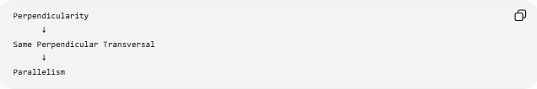
Perpendicularity
↓
Same Perpendicular Transversal
↓
Parallelism

Perpendicularity and the Pythagorean Theorem
# Source: AI Source: Provided by: [Data Path: Persons Table -> ID Column: 1, Name_En Column: Motasem Essam] -> From: [ChatGPT] on [7/25/2026]
Perpendicularity creates right triangles, allowing the Pythagorean theorem to be applied.
If:
$$AB⊥AC,$$
then triangle $ABC$is right-angled at $A$.
Therefore:
$$\boxed{BC^{2}=AB^{2}+AC^{2}}.$$
Example
If:
$$AB=3, AC=4,$$
then:
$$BC^{2}=3^{2}+4^{2} \\ BC^{2}=25$$
so:
$$\boxed{BC=5}.$$

Perpendicularity and Loci
# Source: AI Source: Provided by: [Data Path: Persons Table -> ID Column: 1, Name_En Column: Motasem Essam] -> From: [ChatGPT] on [7/25/2026]
Perpendicularity appears naturally in locus problems.
Perpendicular bisector
The locus:
$$PA=PB$$
is the perpendicular bisector of $AB$.
Fixed distance from a line
The locus:
$$d\left(P , l\right)=r$$
consists of two lines parallel to $l$.
The perpendicular segments connecting those parallel lines to $l$have length $r$.
Thus perpendicularity provides the direction of shortest-distance measurement.

Important Special Cases
# Source: AI Source: Provided by: [Data Path: Persons Table -> ID Column: 1, Name_En Column: Motasem Essam] -> From: [ChatGPT] on [7/25/2026]
Perpendicular bisector
$$\boxed{AM=MB ∧ l⊥AB}$$
Altitude
$$\boxed{D∈BC ∧ AD⊥BC}$$
Right triangle
$$\boxed{AB⊥AC}$$
Rectangle
$$\boxed{AB⊥BC, BC⊥CD, CD⊥DA, DA⊥AB}$$
Square
A square combines:
$$\text{perpendicular sides}$$
with:
$$\text{equal side lengths}.$$

Perpendicularity vs Parallelism
# Source: AI Source: Provided by: [Data Path: Persons Table -> ID Column: 1, Name_En Column: Motasem Essam] -> From: [ChatGPT] on [7/25/2026]
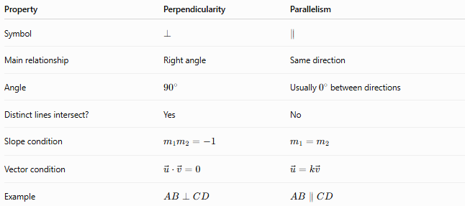
Property | Perpendicularity | Parallelism
Symbol | $$⊥$$ | $$∥$$
Main relationship | Right angle | Same direction
Angle | $${90}^{∘}$$ | Usually $0^{∘}$between directions
Distinct lines intersect? | Yes | No
Slope condition | $$m_{1}m_{2}=-1$$ | $$m_{1}=m_{2}$$
Vector condition | $$\vec{u}⋅\vec{v}=0$$ | $$\vec{u}=k\vec{v}$$
Example | $$AB⊥CD$$ | $$AB∥CD$$

Perpendicularity vs Right Angle
# Source: AI Source: Provided by: [Data Path: Persons Table -> ID Column: 1, Name_En Column: Motasem Essam] -> From: [ChatGPT] on [7/25/2026]
These concepts are closely related but refer to slightly different things.
A right angle is an angle whose measure is:
$${90}^{∘}.$$
Perpendicularity describes the relationship between objects that form right angles.
Thus:
$$\boxed{\text{Right Angle}→\text{Angle Property}}$$
while:
$$\boxed{\text{Perpendicularity}→\text{Relationship Between Objects}}$$
Example:
$$m∠ABC={90}^{∘}$$
is a right-angle condition, while:
$$AB⊥BC$$
is a perpendicularity condition.

Key Formulas
# Source: AI Source: Provided by: [Data Path: Persons Table -> ID Column: 1, Name_En Column: Motasem Essam] -> From: [ChatGPT] on [7/25/2026]
Right angle
$$\boxed{θ={90}^{∘}=\frac{π}{2}}$$
Line notation
$$\boxed{l_{1}⊥l_{2}}$$
Slope condition
$$\boxed{m_{1}m_{2}=-1}$$
for non-vertical, non-horizontal lines.
Vector condition
$$\boxed{\vec{u}⋅\vec{v}=0}$$
Dot product
$$\boxed{\vec{u}⋅\vec{v}=u_{1}v_{1}+u_{2}v_{2}}$$
Point-to-line shortest distance
$$\boxed{PH≤PQ}$$
where:
$$PH⊥l, Q∈l.$$
Pythagorean theorem
$$\boxed{c^{2}=a^{2}+b^{2}}$$
when $a⊥b$.
Pythagorean converse
$$\boxed{a^{2}+b^{2}=c^{2}⇒a⊥b}$$
under the appropriate triangle configuration.
Perpendicular bisector
$$\boxed{PA=PB}$$
for every $P$on the perpendicular bisector of $AB$.

Classification Summary
# Source: AI Source: Provided by: [Data Path: Persons Table -> ID Column: 1, Name_En Column: Motasem Essam] -> From: [ChatGPT] on [7/25/2026]
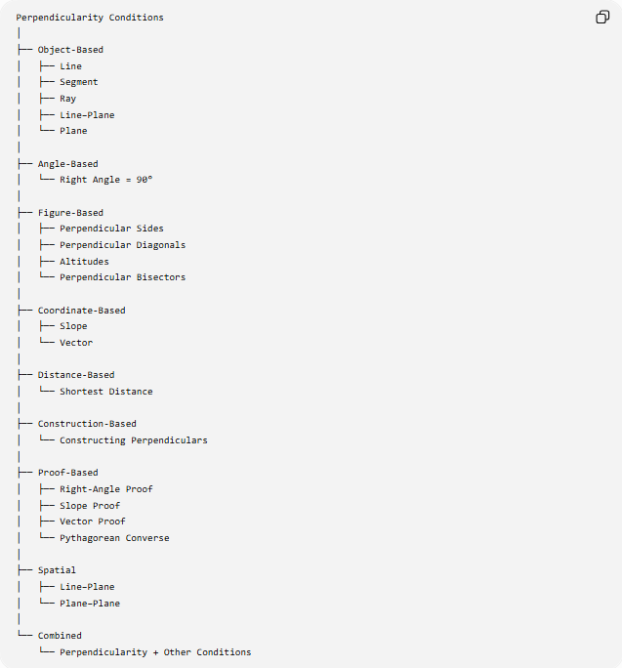
Perpendicularity Conditions
│
├── Object-Based
│ ├── Line
│ ├── Segment
│ ├── Ray
│ ├── Line–Plane
│ └── Plane
│
├── Angle-Based
│ └── Right Angle = 90°
│
├── Figure-Based
│ ├── Perpendicular Sides
│ ├── Perpendicular Diagonals
│ ├── Altitudes
│ └── Perpendicular Bisectors
│
├── Coordinate-Based
│ ├── Slope
│ └── Vector
│
├── Distance-Based
│ └── Shortest Distance
│
├── Construction-Based
│ └── Constructing Perpendiculars
│
├── Proof-Based
│ ├── Right-Angle Proof
│ ├── Slope Proof
│ ├── Vector Proof
│ └── Pythagorean Converse
│
├── Spatial
│ ├── Line–Plane
│ └── Plane–Plane
│
└── Combined
└── Perpendicularity + Other Conditions

Key Points
# Source: AI Source: Provided by: [Data Path: Persons Table -> ID Column: 1, Name_En Column: Motasem Essam] -> From: [ChatGPT] on [7/25/2026]
- Perpendicularity Conditions require geometric objects to meet at right angles.
- The fundamental notation is:
$$\boxed{l_{1}⊥l_{2}}.$$
- The defining angle is:
$$\boxed{{90}^{∘}}.$$
- Perpendicular lines intersect in the Euclidean plane.
- Two non-vertical lines are perpendicular when:
$$\boxed{m_{1}m_{2}=-1}.$$
- Two vectors are perpendicular when:
$$\boxed{\vec{u}⋅\vec{v}=0}.$$
- A perpendicular segment gives the shortest distance from a point to a line.
- A perpendicular bisector combines:
$$\text{perpendicularity}+\text{midpoint}.$$
- An altitude combines:
$$\text{incidence}+\text{perpendicularity}.$$
- Perpendicularity creates right triangles and therefore connects directly to the Pythagorean theorem.
- Two lines perpendicular to the same line are parallel in Euclidean plane geometry.
- Perpendicularity is fundamental to right triangles, altitudes, perpendicular bisectors, rectangles, squares, rhombi, coordinate geometry, vector geometry, constructions, loci, and geometric proofs.

Conclusion
# Source: AI Source: Provided by: [Data Path: Persons Table -> ID Column: 1, Name_En Column: Motasem Essam] -> From: [ChatGPT] on [7/25/2026]
Perpendicularity Conditions specify that two geometric objects meet at a right angle. The fundamental condition is:
$$\boxed{l_{1}⊥l_{2}}$$
which is equivalent, for intersecting planar lines, to:
$$\boxed{∠\left(l_{1} , l_{2}\right)={90}^{∘}}.$$
Perpendicularity can be expressed through several mathematical frameworks:
$$\boxed{\begin{aligned}&\text{Angle:}&&θ={90}^{∘} \\ &\text{Slope:}&&m_{1}m_{2}=-1 \\ &\text{Vector:}&&\vec{u}⋅\vec{v}=0 \\ &\text{Distance:}&&PH=d\left(P , l\right) \\ &\text{Triangle:}&&a^{2}+b^{2}=c^{2}\end{aligned}}$$
Therefore, perpendicularity is a fundamental geometric condition connecting right angles, shortest distances, parallelism, altitudes, perpendicular bisectors, coordinate geometry, vectors, constructions, loci, spatial geometry, and geometric proofs.

